 | 7.0.12 Editors - 3D Viewport - Grease Pencil object - Edit Mode - Point context menu
Table of content
Detailed table of content 1
Edit Mode - Point Context Menu 4
Extrude 4
Subdivide 5
Subdivide and Smooth 5
Smooth Points 6
Set Start Point 7
Mirror sub menu 7
Snap sub menu 8
Duplicate 8
Copy 9
Paste 9
Dissolve 9
Dissolve Between 9
Dissolve Unselect 9
Simplify Strokes sub menu 10
Outline 10
Separate 11
Convert Type 11

Detailed table of content
Detailed table of content
Detailed table of content 1
Edit Mode - Point Context Menu 4
Extrude 4
Last Operator Extrude Stroke Points 4
Move 4
Orientation 4
Mirror Editing 4
Proportional editing 4
Proportional Falloff 4
Proportional Size 4
Connected 5
Projected(2D) 5
Subdivide 5
Last Operator Subdivide 5
Number of Cuts 5
Smooth 5
Repeat 5
Selected Points 5
Position 5
Thickness 5
Strength 5
UV 5
Subdivide and Smooth 5
Last Operator Subdivide and Smooth 6
Number of Cuts 6
Selected Points 6
Iterations 6
Factor 6
Smooth Endpoints 6
Keep Shape 6
Position 6
Radius 6
Opacity 6
Smooth Points 6
Last Operator Smooth Stroke 6
Repeat 6
Factor 6
Selected points 6
Position 7
Thickness 7
Strength 7
UV's 7
Set Start Point 7
Mirror sub menu 7
Interactive Mirror 7
X Global, Y Global etc. 7
Last Operator Mirror 7
Orientation 7
Constraint Axis 8
Snap sub menu 8
Last Operator Snap 8
With Offset 8
Duplicate 8
Last Operator Duplicate 8
Mode 8
Move X, Y, Z 8
Orientation 8
Constraint Axis 8
Proportional editing 8
Proportional Falloff 9
Proportional Size 9
Connected 9
Projected(2D) 9
Copy 9
Paste 9
Last operator Paste Strokes 9
Type 9
Dissolve 9
Dissolve Between 9
Dissolve Unselect 9
Last Operator Dissolve 9
Type 9
Simplify Strokes sub menu 10
Fixed 10
Adaptive 10
Sample 10
Merge 10
Last Operator Simplify Stroke 10
Mode 10
Steps (Fixed) 10
Factor (Adaptive) 10
Length (Sample) 10
Distance (Merge) 10
Outline 10
Last Operator Outline 10
Projection Mode 11
Radius 11
Offset Factor 11
Corner Subdivisions 11
Separate 11
Last Operator Separate Strokes 11
Mode 11
Active Layer 11
Selected Strokes 11
Selected Points 11
Convert Type 11
Last Operator Separate Strokes 11
Type 11
Threshold 12

Edit Mode - Point Context Menu

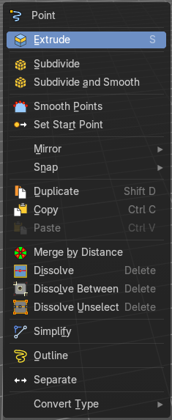
Call this menu with right click in the 3D viewport.
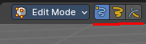

Extrude
Extrude selected points and move them. The new points stay connected with the original points of the stroke.

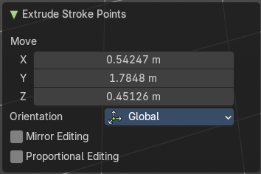
Last Operator Extrude Stroke Points

Move
The vector coordinates. They start relative to the initial vector.

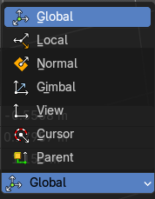
Orientation
The orientation in which the extrude happens.

Mirror Editing
Edit along a mirror axis.

Proportional editing
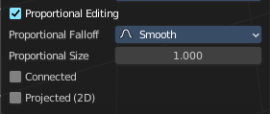
Enables proportional editing. Activating proportional editing reveals further settings.

Proportional Falloff
Adjust the falloff methods.

Proportional Size
See and adjust the falloff radius.

Connected
The proportional falloff gets calculated for connected parts only.

Projected(2D)
The proportional falloff gets calculated in the screen space. Depth doesn't play a role. When it's in the radius, then it gets calculated.

Subdivide
Subdivides the selected grease pencil geometry.

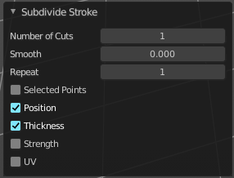
Last Operator Subdivide

Number of Cuts
Number of subdivision cuts.

Smooth
Smoothen the stroke, not just the new added vertices

Repeat
The number of times to repeat the procedure.

Selected Points
Limits the effect to only the selected points within the stroke.

Position
The operator affects the points location.

Thickness
The operator affect the points thickness.

Strength
The operator affect the points strength (alpha).

UV
The operator affect the UV rotation on the points.

Subdivide and Smooth
Subdivides the selected grease pencil geometry.

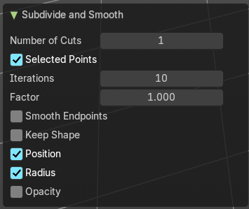
Last Operator Subdivide and Smooth

Number of Cuts
Number of subdivision cuts.

Selected Points
Limits the effect to only the selected points within the stroke.

Iterations
Number of iterations.

Factor
Smooth factor

Smooth Endpoints
Smooth endpoints too.

Keep Shape
Keep the overall shape.

Position
The operator affects the points location.

Radius
Smooth radius.

Opacity
Smooth Opacity.

Smooth Points
Smoothens out the selected geometry.

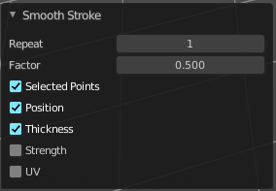
Last Operator Smooth Stroke

Repeat
How often to repeat the procedure.

Factor
The amount of the smoothness to apply.

Selected points
When enabled, limits the effect to only the selected points within the stroke.

Position
When enabled, the operator affect the points location.

Thickness
When enabled, the operator affect the points thickness.

Strength
When enabled, the operator affect the points strength (alpha).

UV's
When enabled, the operator affect the UV rotation on the points.
in the screen space. Depth doesn't play a role. When it's in the radius, then it gets calculated.
calculated in the screen space. Depth doesn't play a role. When it's in the radius, then it gets calculated.

Set Start Point
Select which point is the start point of the grease pencil curve. This defines the order of point indices, useful for Geometry nodes.
Note: Not available in stroke selection mode.

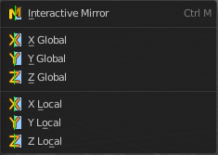
Mirror sub menu
Mirror mirrors the selected geometry along the defined axis.

Interactive Mirror
Mirror by hotkeys. You activate the tool, type in x for x global for example, or x x for x local. And the selection gets mirrored.

X Global, Y Global etc.
Mirrors the selection around the chosen axis.

Last Operator Mirror
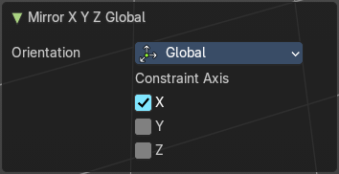
The Last Operator Mirror panel gives you tools to adjust the mirror action.


Orientation
Orientation is a drop-down box. Choose the type of orientation for the mirroring action.

Constraint Axis
Constraint Axis gives you again the possibility to define the mirror axis. You can choose more than one axis here.

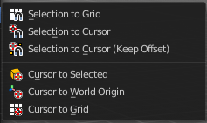
Snap sub menu
Choose several methods to snap one element to another. The menu items should be self explaining.

Last Operator Snap

Some snap operations shows a last operation panel, some not.

With Offset
If the selection should snap as a whole, or if each individual element of the selection should snap.

Duplicate
Duplicates the current selection.
When you duplicate a selection, then it sticks to the mouse until you left click. And moves around. A right click repositions the duplicated geometry at its original location.

Last Operator Duplicate

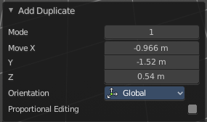
Mode
Not to find out. No tool tip, no entry in the Blender manual. Good Job Blender Developers.

Move X, Y, Z
Adjust the position.

Orientation
Orientation is a drop-down box. Choose the type of orientation for the mirroring action.

Constraint Axis
Constraint Axis gives you again the possibility to define the mirror axis. You can choose more than one axis here.


Proportional editing
Enables proportional editing. Activating proportional editing reveals further settings.

Proportional Falloff
Adjust the falloff methods.

Proportional Size
See and adjust the falloff radius.

Connected
The proportional falloff gets calculated for connected parts only.

Projected(2D)
The proportional falloff gets calculated in the screen space. Depth doesn't play a role. When it's in the radius, then it gets calculated.

Copy
Copies the selection.

Paste
Pastes a copied selection to active layer. You can have more than one layer.

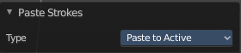
Last operator Paste Strokes

Type
Choose between the paste methods again.

Dissolve
Dissolves the selection.

Dissolve Between
Dissolves the vertices between the selected vertices.

Dissolve Unselect
Dissolves the vertices that are not selected.

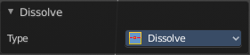
Last Operator Dissolve

Type
Choose how you want to dissolve.

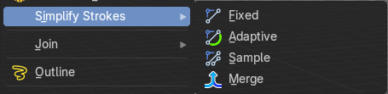
Simplify Strokes sub menu
Stroke mode. Simplify the stroke.

Fixed
Deletes every second point in the stroke, except the start and end points.

Adaptive
This method uses an algorithm called RDP algorithm (Ramer-Douglas-Peucker algorithm) for points deletion. The algorithm tries to keep the shape with the remaining points.

Sample
Samples points along the shape of the stroke, and increases the length of the edges.

Merge
Simplify the stroke by merging vertices closer than a given distance.

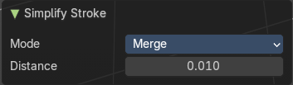
Last Operator Simplify Stroke
The simplify strokes operators share the same last operator.

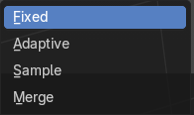
Mode
The method.

Steps (Fixed)
How much levels of simplifying.

Factor (Adaptive)
How strong the simplification should be performed.

Length (Sample)
The sample length.

Distance (Merge)
The distance. Below this value the vertices gets merged.

Outline
Adds an outline to the grease pencil.

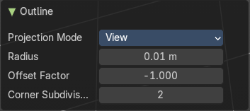
Last Operator Outline

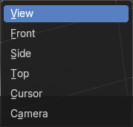
Projection Mode
The orientation to project the outline.

Radius
Thickness of the outline

Offset Factor
Offset from original outline.

Corner Subdivisions
How much iterations to subdivide the corners.

Separate
Separates the selection into a new grease pencil object.

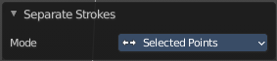
Last Operator Separate Strokes

Mode

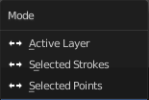
Active Layer
Separate all the strokes at the current active layer.

Selected Strokes
Separate the whole stroke of the current selection.

Selected Points
Separate the selected points with its edges.

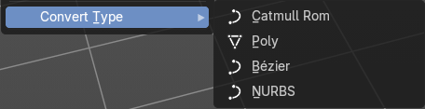
Convert Type
Convert the curve type of the grease pencil to another curve type. These different curve types allows you different ways of modification.

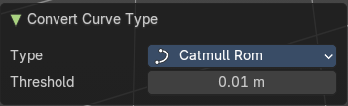
Last Operator Separate Strokes

Type
The curve types.

Threshold
The distance that the resulting points are allowed to be within.

